1. Road Map for this and future lectures.   
   Graphical user interface

   Description automatically generated with medium confidence
2. Keep in mind that a stubs added by us will not be saved into mapping file automatically unless we ask.   
   So, as soon as we stop WireMock Server, those stubs are gone.
3. **Let’s first see how to fetch an already added stub through API**.  
   We will see how to fetch one single stub.   
   Graphical user interface, application

   Description automatically generated with medium confidence
4. **Let’s see how to fetch all the mappings/stubs  
   Suppose we have two stubs added.**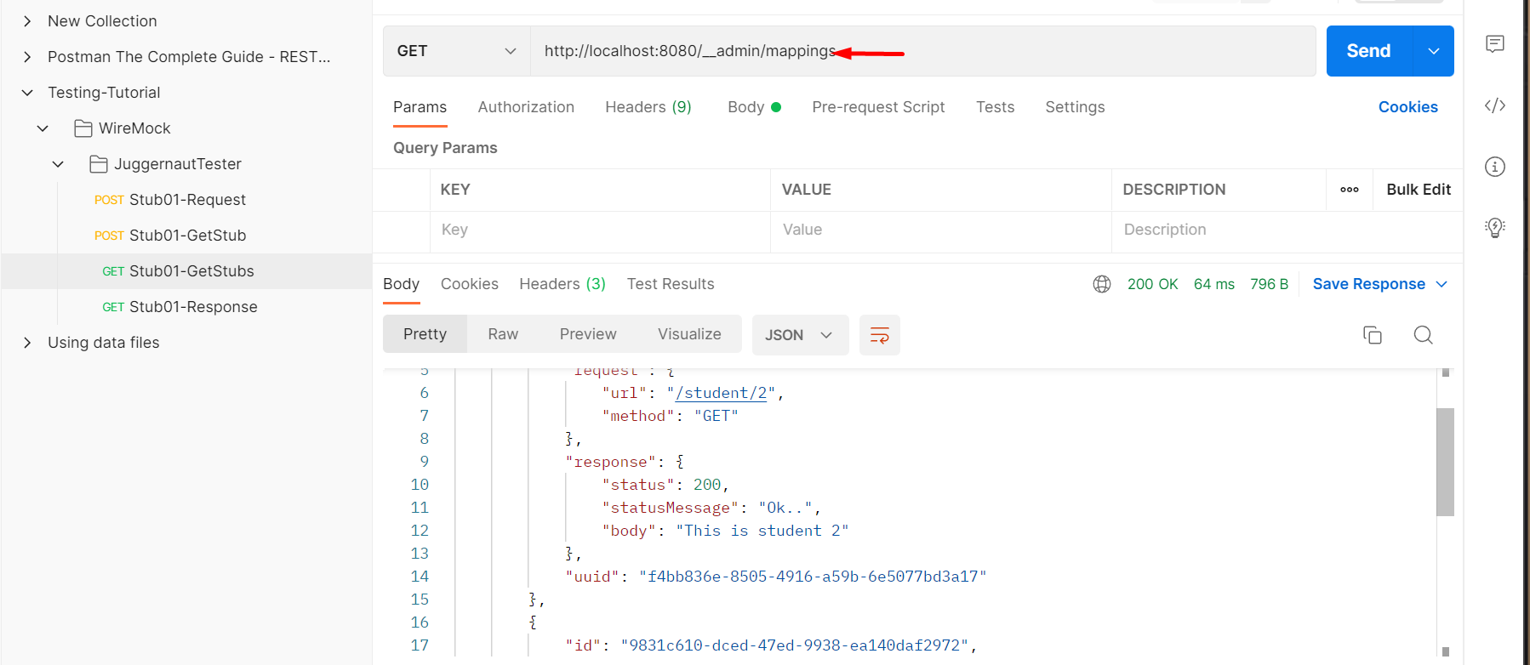
5. **Let’s save stubs**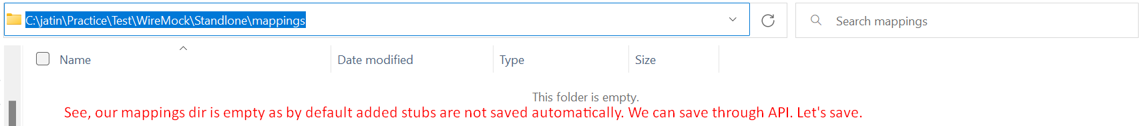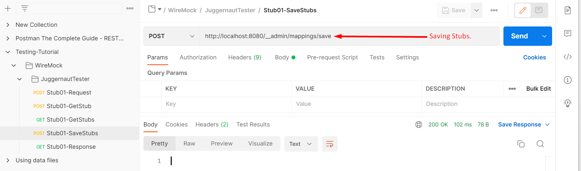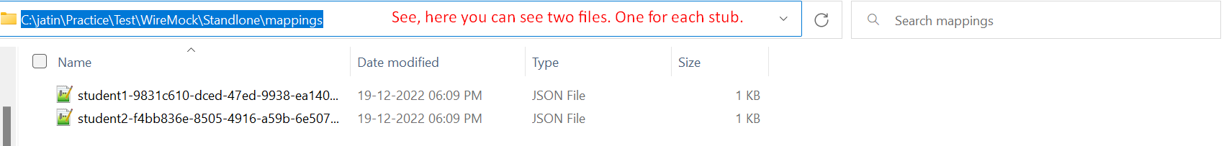Graphical user interface, text, application

   Description automatically generated
6. **Deleting a saved stub.**Graphical user interface, text, application, email

   Description automatically generated